1. Make all your pages in page library to put their links into top navigation menu
2. Goto site settings >> Navigation >> tick mark “show all pages”

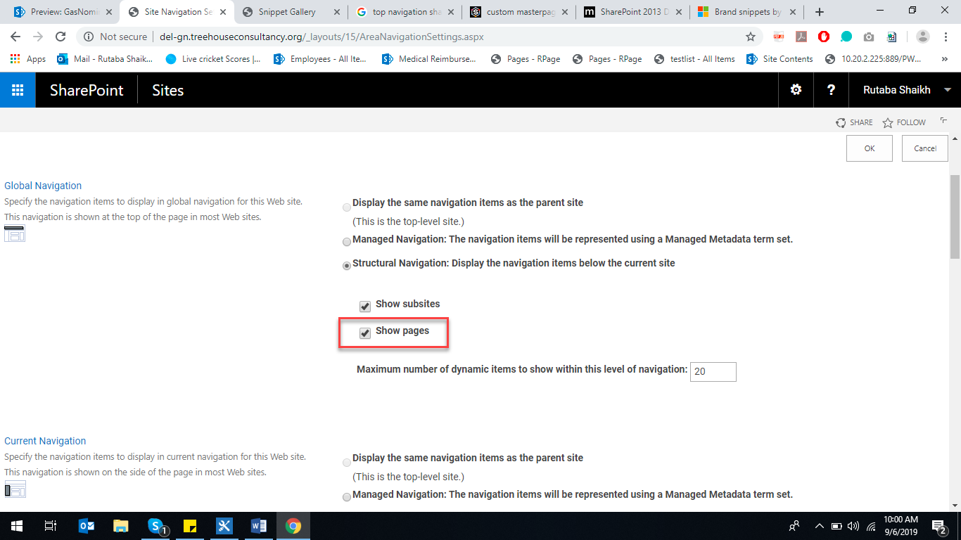

1. Your pages will be shown in if u scroll down a little

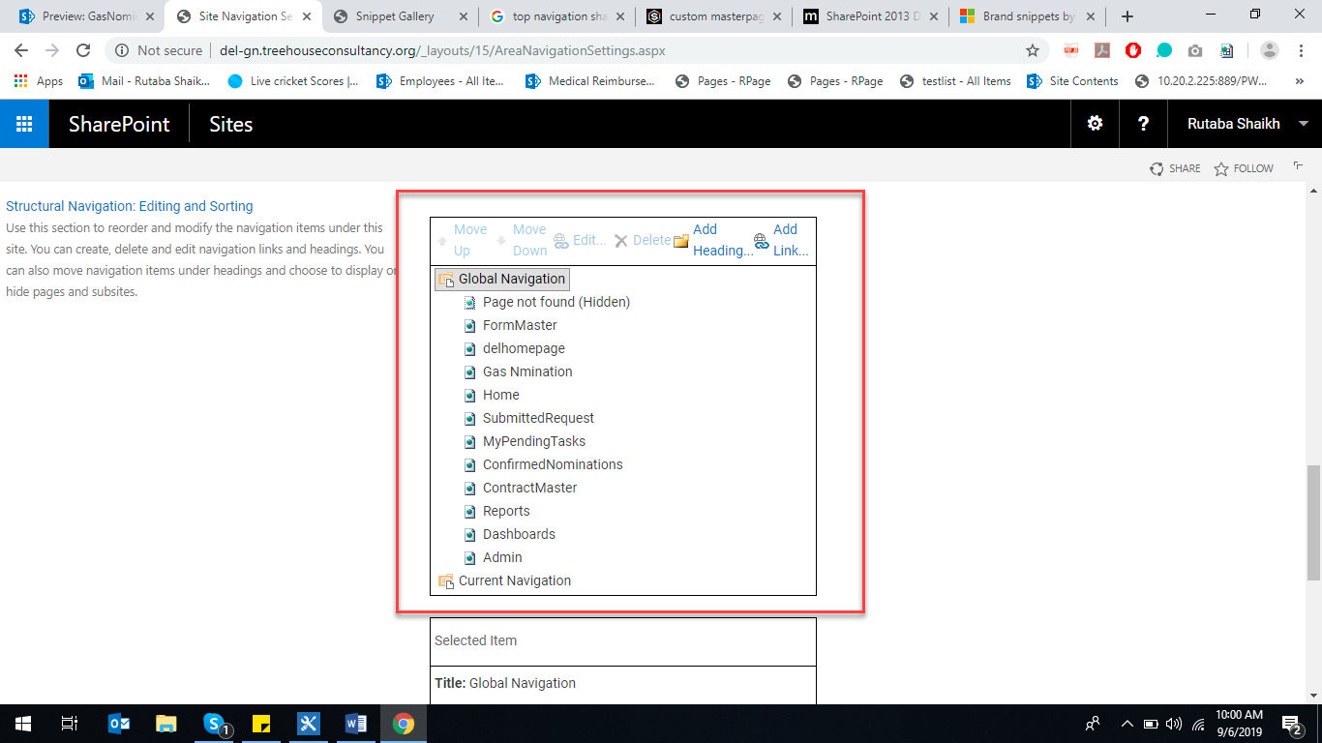

1. Click ok
2. Goto design manager >> Edit Master Pages >> under Design tab click on Top Navigation, your pages are showing in preview.

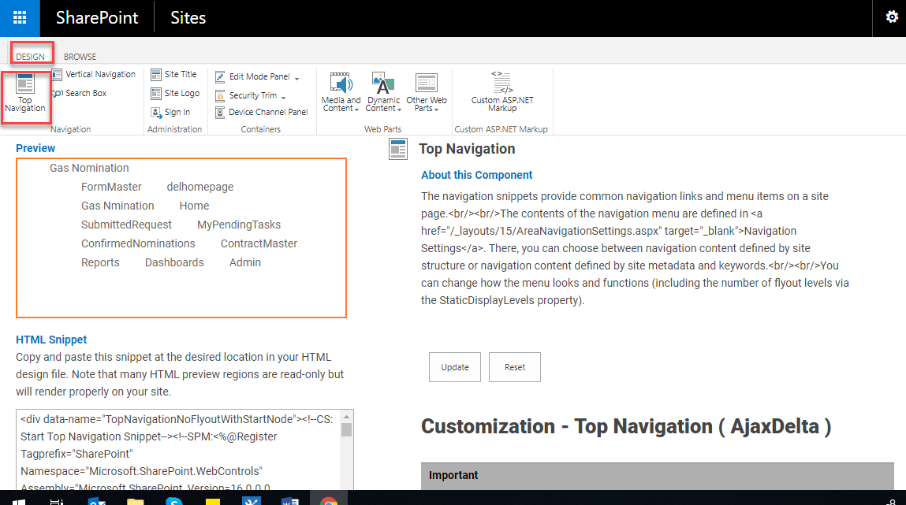

1. Select “Rendering Mode” to list so html would be in list (i.e. <ul><li></li></ul>) and press update button

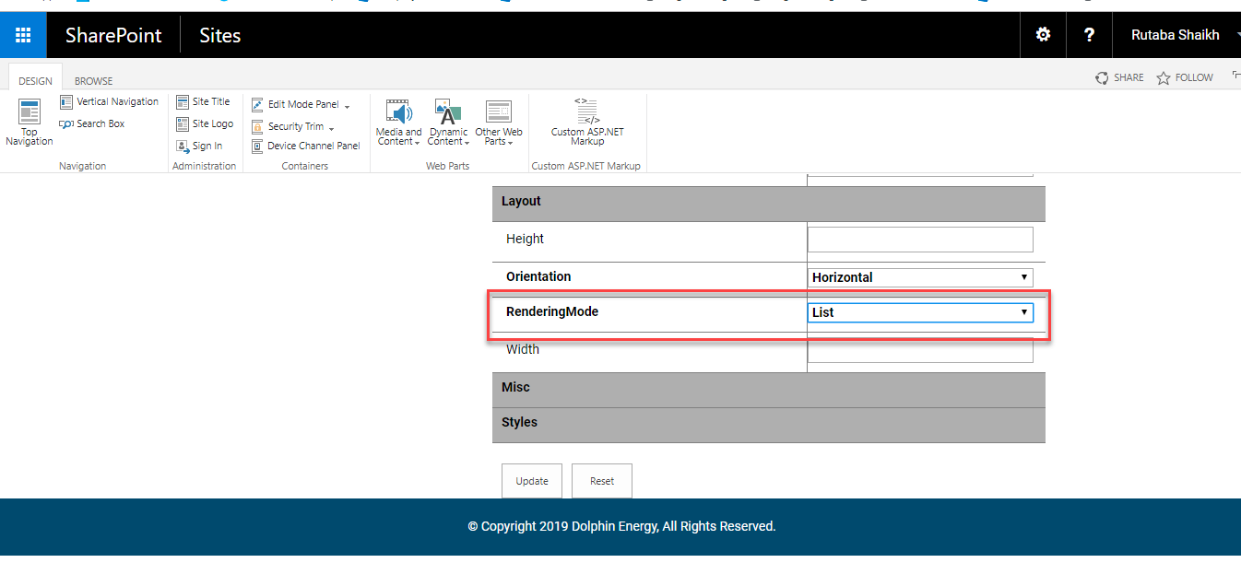

1. Static Display level shows level of menu

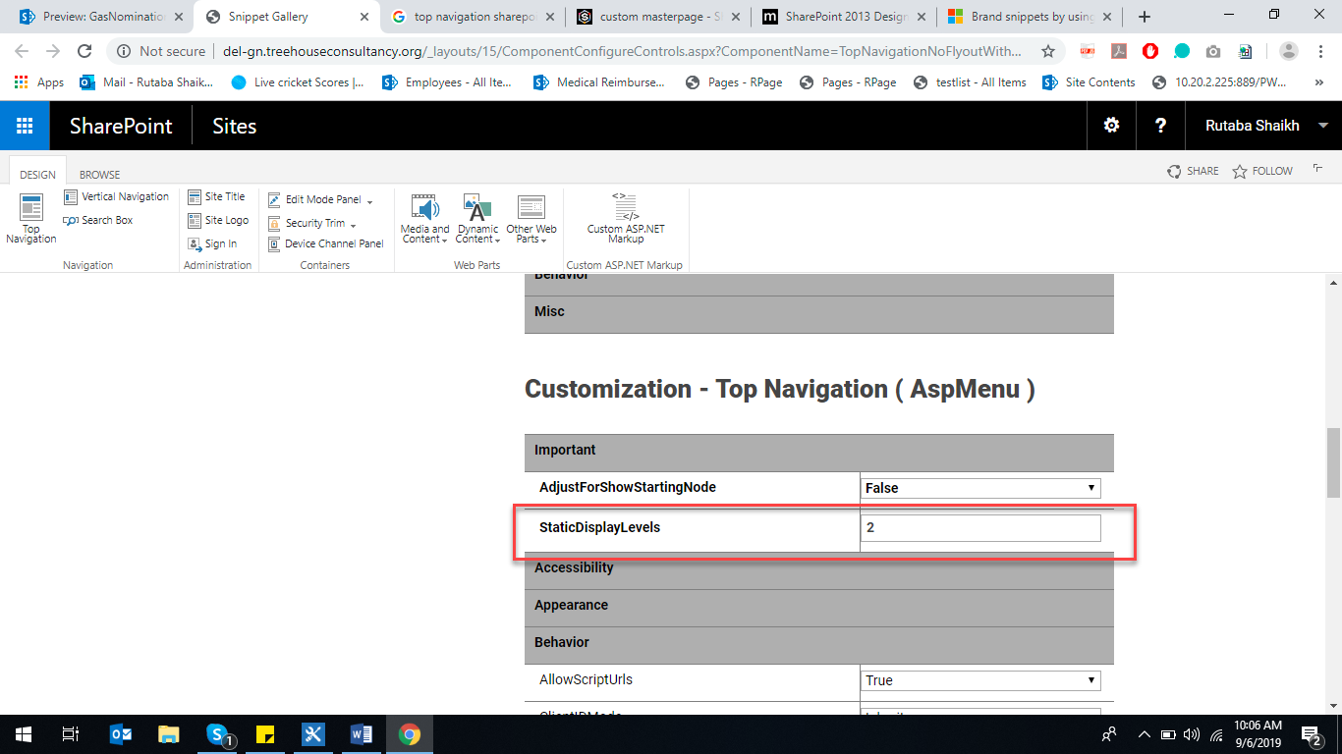

1. Copy your html in sharepoint designer

